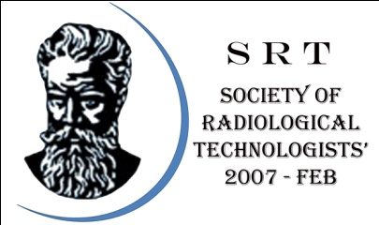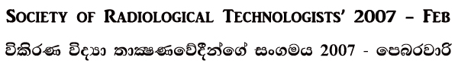OFFICE ADDRESS: Chanaka Rangajeewa, N0 123, 11th Lane, Araliya Uyana, Depanama, Pannipitiya.
SECRETARY: 0715106105–Rajitha PRESIDENT: 0718658620-Chanaka TREASRURE: 0714486255-Samantha.
E-Mail – srt2007feb@gmail.com Web- srt2007feb.weebly.com - srtfeb

The Report of the 1st Annual General Meeting of the
Society of Radiological Technologist’s 2007 Feb
The 1st Annual General Meeting of the SRT 2007 – FEB was held on 10th October in 2010 commencing at 8.00 am at the “ Awanhala ” Restaurant in Kandy presided over by the Mr. Rajitha Parindra Bandara who welcomed all the members.
According to the agenda Mr. Rajitha invited all participants to observance of one min. silence in memory of the members passed away & war heroes.
As next item Mr. Rajitha invited members to appoint the posts of secretary, President , Treasure , vice president & vice secretary. Then Mr. Rajitha appointed as the secretary , Mr. Chanaka appointed as the president & Mr. Samantha appointed as the treasure. Those members proposed & seconded by Mr.Ruwan & Mr. Kasun respectively. Ms. Nishadi appointed as the vice president. It was proposed & seconded by Mr. Deshan & Mr Chathura. Mr. Rasika appointed as the vice secretary. It was proposed & seconded by Mr. Ranil & Mr Dinesh.
As next item Hon. President Mr. Chanaka invited members to appoint the posts of Provincial coordinators. Then following members appointed as Provincial coordinators.Western province - Mr.Rajitha , proposed & seconded by Mr. Chathura & Mr Saman. Central province - Mr.Jagath , proposed & seconded by Mr. Lahiru & Mr Ruwan. Eastern province - Mr.Rasika , proposed & seconded by Mr. Athula & Mr Iresh. Uva province - Mr.Kasun , proposed & seconded by Mr. Chanaka & Mr Chaminda. North West province - Mr.Nalaka , proposed & seconded by Mr. Dayan & Mr Sanjeewa. North Central & North provinces - Mr.Ranil , proposed & seconded by Mr. Sumith & Mr Nuwan Kumara. Sabaragamuwa province - Mr.Deshan , proposed & seconded by Mr. Dinesh & Mr Aruna. Southern province - Mr.Thilina , proposed & seconded by Ms.Nishadi & Mr Sisira. Forces - Mr.Samantha , proposed & seconded by Mr. Kumara & Mr Rathnayaka.
According to the agenda Hon. President invited the Gen. secretary to read the constitution of the Society of Radiological Technologist’s 2007-Feb. Mr. Rajitha was duly read that & explain the rules , benefits for the members. next item was to discussed about the constitution & adopt the constitution. Then all members agree with the constitution , It was proposed & seconded by Mr. Nalaka & Mr Saman respectively.
After that under the any other business following topics were discussed.
- Mr. Nishshanka who works at Monaragala Hospital proposed to arrange some lectures for improving our members knowledge about Radiography.
- Mr. Rasika proposed to annual get together of 2007-Feb batch will conduct different province of the country.
- Mr. Gayan & Mr.Pradeep discussed about their transfers.
- Mr. Nalaka proposed to make a list of unqualified Radiographers in the country & discussed with the mother union about that.
Hon. President Mr. Chanaka & Gen. Secretary Mr. Rajitha discussed with members about those matters & agreed to give immediate solutions for each matters as they can. Mr. Saranga proposed to next annual get – together will held in Colombo. All the members agreed that .
Then the AGM was end up at 12.35 pm & Get – Together party was started.

…………………………..
Rajitha Parindra Bandara
Gen. Secretary

